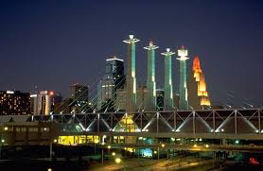
THE DOWN TOWN
The simplest package

• 30 minute use of The Chapel
• 25 guest maximum including participants in ceremony (not including the couple and service providers)
• Complimentary officiant to perform ceremony
(couple may decline officiant to bring in their own)
The couple is granted the freedom to provide their own photographer or personal flowers if they so choose.
• Book this package with a $250 non-refundable booking deposit.
• Remaining balance due on date of event.
• Available 7 days a week

$500

($750 if event falls on a holiday week or weekend)

